

PROJECT:

Super Market

Management System

Submitted By:

Mohammed Saqhib Bilal

12-‘C’

M.M.E.I.S

**MODERN MIDDLE EAST INTERNATIONAL SCHOOL**



**DEPARTMENT OF COMPUTER SCIENCE**

CERTIFICATE

This is to certify that Mr. Safdar of Class XII C has satisfactorily completed her Computer Project on THE SUPER MARKET SYSTEM under my guidance.

*Name and Signature of the Teacher in Charge*

*School Seal*

This project report submitted for the AISSCE practical examination conducted on ____________has been evaluated by me.

*Name and signature of the External Examiner*

Examination Centre:

Date:

ACKNOWLEDGEMENT:

I would like to thank my computer sir, Mr. Vimal Vijay (Faculty in Computer Science), for his able guidance and support exhibited by him in the completion of this project.

It gives me great pleasure in presenting this project. We extend our gratitude to my friends for conveying their valuable suggestions to improve the quality of this project and its value.

This project has contributed invariably in improving and increasing my knowledge about C++ programming language which will hopefully prove to be profitable for me in future.

INDEX:

1.Overview of C++

2.System Requirements

3.About the Project

4.Source Code

5.Sample Output

6.Bibliography

OVERVIEW OF C++:

C++ is a statically typed, free-form, multi-paradigm, compiled, general-purpose programming. It is regarded as an intermediate-level language, as it comprises a combination of both high and low-level language features. Developed by Bjarne Stroustrup starting in 1979 at Bell Labs, it adds object-oriented features, such as classes, and other enhancements to the C programming language. Originally named C with Classes, the language was renamed C++ in 1983, as a pun involving the increment operator.

C++ is one of the most popular programming languages and is implemented on a wide variety of hardware and operating system platforms. As an efficient compiler to native code, its application domains include systems software, application software, device drivers, embedded software, high-performance server and client applications, and entertainment software such as video games. Several groups provide both free and proprietary C++ compiler software, including the GNU Project, Microsoft, Intel and Embarcadero Technologies. C++ has greatly influenced many other popular programming languages, most notably C# and Java. Other successful languages such as Objective-C use a very different syntax and approach to adding classes to C.

C++ is also used for hardware design, where the design is initially described in C++, then analyzed, architecturally constrained, and scheduled to create a register-transfer level hardware description language via high. The language began as enhancements to C, first adding classes, then virtual functions, overloading, multiple, templates and exception handling among other features. After years of development, the C++ programming language standard was ratified in 1998 as ISO/IEC 14882:1998. The standard was amended by the 2003 technical corrigendum, ISO/IEC 14882:2003. The current standard extending C++ with new features was ratified and published by ISO in September 2011 as ISO/IEC 14882:2011 (informally known as C++11).

SYSTEM REQUIREMENTS:

Minimum Hardware Requirements:

Processor: Inter Pentium IV or above

RAM: 512 MB or above

Hard disk: 40 GB or above

Minimum Software Requirements:

Operating System Windows: Windows 9 or above

Tools: Turbo C++ 3.0

Technologies: DOS 7.0

ABOUT THE C++ PROJECT:

Super Market

This C++ project is the standard super market system. When we compile the ASIS.cpp file in a C++ supported compiler, the executable file is generated (i.e. the program). The super market system works with the file ‘products.dat’. It contains the data from the program variables. The data file will be generated automatically if it is not present there.

**THE PROGRAM RUNS AS FOLLOWS:**

* Searches the file containing the data (products.dat).
* Shows the welcome screen.
* Shows the main menu for administrator and customer.
* Administrator- can add, modify, delete products.
* Customer- can purchase as well as have a look at the list of products.

Advantage of the program:

This program makes the work much easier and faster. It reduces the human effort for keeping the product details and their purchase records. It is a user-friendly program where anyone can manage the system.

SOURCE CODE:

**//Header files used are:**

#include<iostream.h>

#include<conio.h>

#include<stdio.h>

#include<process.h>

#include<fstream.h>

class product

{

int pno;

char name[50];

float price, qty, tax, dis;

public:

void create_product()

{

cout<<"\nEnter the product number of the Product: ";

cin>>pno;

cout<<"\n\nEnter the name of the Product: ";

gets(name);

cout<<"\nEnter the price of the Product: ";

cin>>price;

cout<<"\nEnter the Discount (%) of the Product: ";

cin>>dis;

}

void show_product()

{

cout<<"\nThe product number of the Product: "<<pno;

cout<<"\nThe name of the Product: ";

puts(name);

cout<<"\nThe price of the Product: "<<price;

cout<<"\nDiscount of the Product: "<<dis;

}

int retpno()

{

return pno;

}

float retprice()

{

return price;

}

char* retname()

{

return name;

}

int retdis()

{

return dis;

}

};

**//global declaration for stream object and object-**

fstream fp;

product pr;

**//function to write in file**

void write_product()

{

fp.open("Shop.dat",ios::out|ios::app);

pr.create_product();

fp.write((char*)&pr,sizeof(product));

fp.close();

cout<<"\n\nThe Product Has Been Created ";

getch();

}

//function to read all records from file

void display_all()

{

clrscr();

cout<<"\n\n\n\t\tDISPLAY ALL RECORD.\n\n";

fp.open("Shop.dat",ios::in);

while(fp.read((char*)&pr,sizeof(product)))

{

pr.show_product();

cout<<"\n\n====================================\n";

getch();

}

fp.close();

getch();

}

**//function to read specific record from file**

void display_sp(int n)

{

int flag=0;

fp.open("Shop.dat",ios::in);

while(fp.read((char*)&pr,sizeof(product)))

{

if(pr.retpno()==n)

{

clrscr();

pr.show_product();

flag=1;

}

}

fp.close();

if(flag==0)

cout<<"\n\nRecord does not exist.Try Again.";

getch();

}

**//function to modify record of file**

void modify_product()

{

int no,found=0;

clrscr();

cout<<"\n\n\tTo Modify: ";

cout<<"\n\n\tEnter the product number of the Product: ";

cin>>no;

fp.open("Shop.dat",ios::in|ios::out);

while(fp.read((char*)&pr,sizeof(product)) && found==0)

{

if(pr.retpno()==no)

{

pr.show_product();

cout<<"\nEnter the new details od the Product: "<<endl;

pr.create_product();

int pos=-1*sizeof(pr);

fp.seekp(pos,ios::cur);

fp.write((char*)&pr,sizeof(product));

cout<<"\n\n\t Record is Updated.";

found=1;

}

}

fp.close();

if(found==0)

cout<<"\n\n Record Not Found. Try Again";

getch();

}

**//function to delete record of file**

void delete_product()

{

int no;

clrscr();

cout<<"\n\n\n\tDelete Record";

cout<<"\n\nEnter the product number of the Product you want to delete: ";

cin>>no;

fp.open("Shop.dat",ios::in|ios::out);

fstream fp2;

fp2.open("Temp.dat",ios::out);

fp.seekg(0,ios::beg);

while(fp.read((char*)&pr,sizeof(product)))

{

if(pr.retpno()!=no)

{

fp2.write((char*)&pr,sizeof(product));

}

}

fp2.close();

fp.close();

remove("Shop.dat");

rename("Temp.dat","Shop.dat");

cout<<"\n\n\tRecord Deleted.";

getch();

}

**//function to display all products price list**

void menu()

{

clrscr();

fp.open("Shop.dat",ios::in);

if(!fp)

{

cout<<"Error! FILE cannot Open\n\n\n Go To Admin Menu to create a File.";

cout<<"\n\n\n Program is now closing.";

getch();

exit(0);

}

cout<<"\n\n\t\tProduct MENU\n\n";

cout<<"====================================================\n";

cout<<"P.NO.\t\tNAME\t\tPRICE\n";

cout<<"====================================================\n";

while(fp.read((char*)&pr,sizeof(product)))

{

cout<<pr.retpno()<<"\t\t"<<pr.retname()<<"\t\t"<<pr.retprice()<<endl;

}

fp.close();

}

**//function to place order and generating bill for Products**

void place_order()

{

int order_arr[50],quan[50],c=0;

float amt,damt,total=0;

char ch='Y';

menu();

cout<<"\n============================";

cout<<"\n PLACE YOUR ORDER";

cout<<"\n============================\n";

do{

cout<<"\n\nEnter the product number of the Product: ";

cin>>order_arr[c];

cout<<"\nQuantity in number: ";

cin>>quan[c];

c++;

cout<<"\nDo you want to order any other Product? (y/n)";

cin>>ch;

}while(ch=='y' ||ch=='Y');

cout<<"\n\nThank you for placing your Order.";

getch();

clrscr();

cout<<"\n\n********************************INVOICE************************\n";

cout<<"\nPr No.\tPr Name\tQuantity \tPrice \tAmount \tAmount after discount\n";

for(int x=0;x<=c;x++)

{

fp.open("Shop.dat",ios::in);

fp.read((char*)&pr,sizeof(product));

while(!fp.eof())

{

if(pr.retpno()==order_arr[x])

{

amt=pr.retprice()*quan[x];

damt=amt-(amt*pr.retdis()/100);

cout<<"\n"<<order_arr[x]<<"\t"<<pr.retname()<<"\t"<<quan[x]<<"\t\t"<<pr.retprice()<<"\t"<<amt<<"\t\t"<<damt;

total+=damt;

}

fp.read((char*)&pr,sizeof(product));

}

fp.close();

}

cout<<"\n\n\t\t\t\t\tTOTAL= "<<total;

getch();

}

**//Introduction Of the Program-**

void intro()

{

clrscr();

gotoxy(31,11);

cout<<"MEIS SUPER MARKET";

gotoxy(35,14);

cout<<"BILLING";

gotoxy(35,17);

cout<<"PROJECT";

cout<<"\n\nMADE BY : Ashfaq, Safdar, Saquib, Ibrahim";

cout<<"\n\nSCHOOL : Modern Middle East International School";

getch();

}

**//Admin function-**

void admin_menu()

{

clrscr();

char ch2;

cout<<"\n\n\n\tADMIN MENU";

cout<<"\n\n\t1.CREATE PRODUCT";

cout<<"\n\n\t2.DISPLAY ALL PRODUCTS";

cout<<"\n\n\t3.QUERY OF THE PRODUCT";

cout<<"\n\n\t4.MODIFY PRODUCT";

cout<<"\n\n\t5.DELETE PRODUCT";

cout<<"\n\n\t6.VIEW PRODUCT MENU";

cout<<"\n\n\t7.BACK TO MAIN MENU";

cout<<"\n\n\tEnter Your Choice from 1-7: ";

ch2=getche();

switch(ch2)

{

case '1': clrscr();

write_product();

break;

case '2': display_all();

break;

case '3':

int num;

clrscr();

cout<<"\n\n\tEnter the product number: ";

cin>>num;

display_sp(num);

break;

case '4': modify_product();

break;

case '5': delete_product();

break;

case '6': menu();

getch();

case '7':

break;

default:cout<<"\a";

admin_menu();

}

}

**//Main function**

void main()

{

char ch;

intro();

do

{

clrscr();

cout<<"\n\n\n\tMAIN MENU";

cout<<"\n\n\t1. CUSTOMER";

cout<<"\n\n\t2. ADMINISTRATOR";

cout<<"\n\n\t3. EXIT";

cout<<"\n\n\tSelect Your Option from 1-3: ";

ch=getche();

switch(ch)

{

case '1': clrscr();

place_order();

getch();

break;

case '2': admin_menu();

break;

case '3':exit(0);

default :cout<<"\a";

}

}while(ch!='3'); }

THE OUTPUTS:

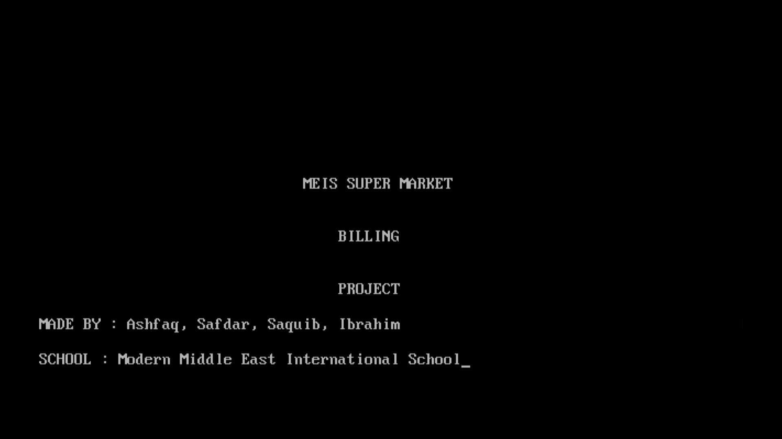Home Screen

Main Menu

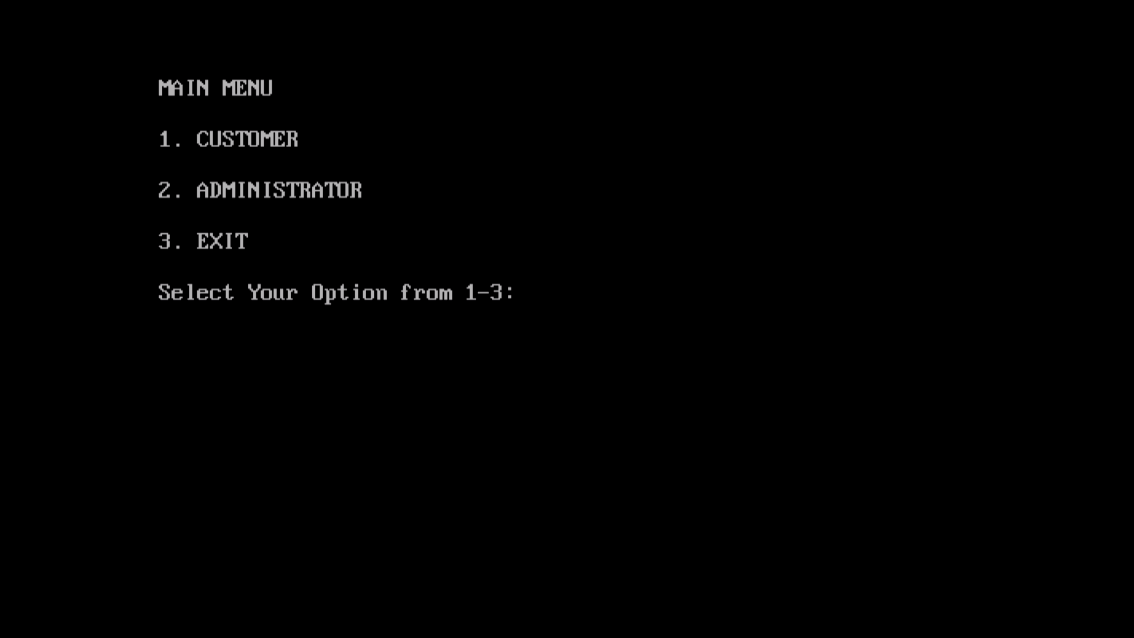

Admin Menu

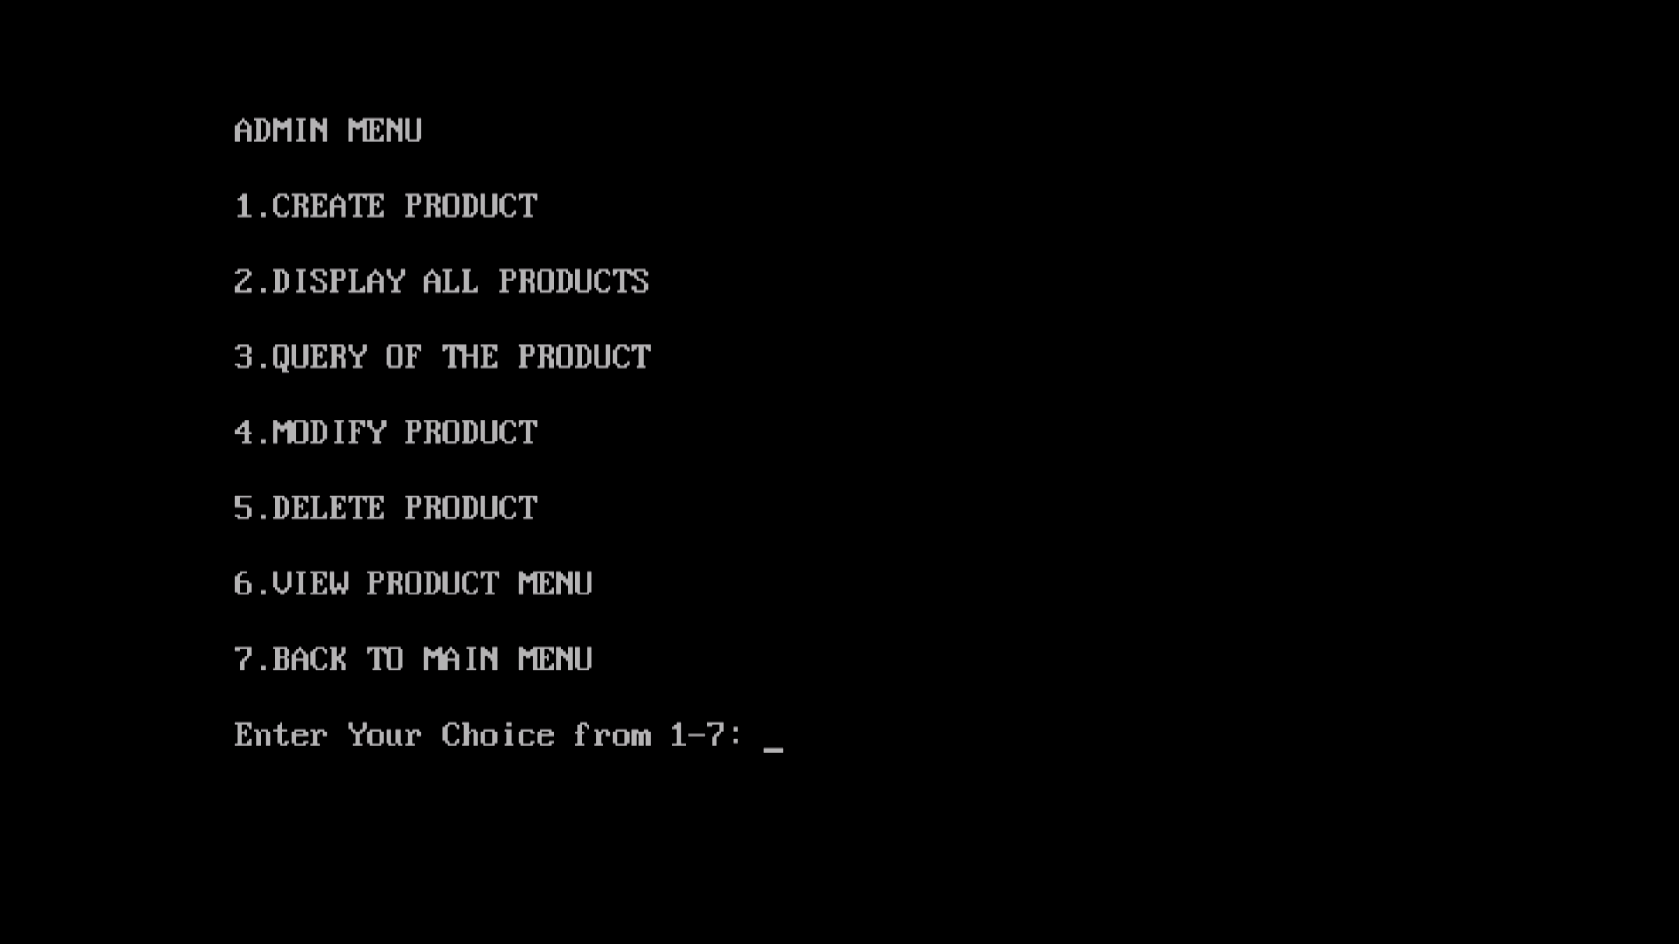

Create Product

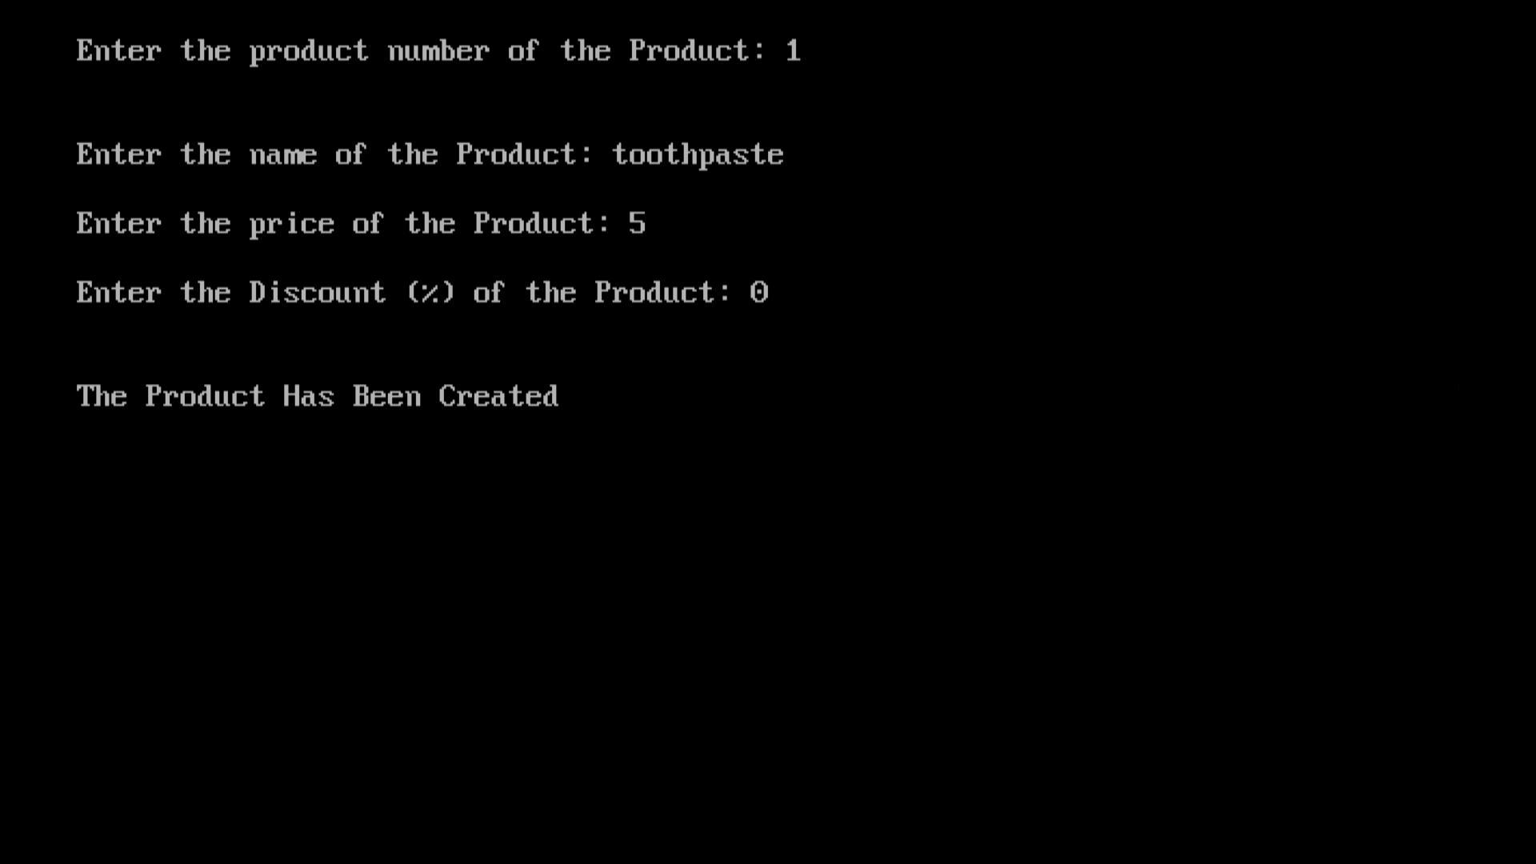

Display All Products

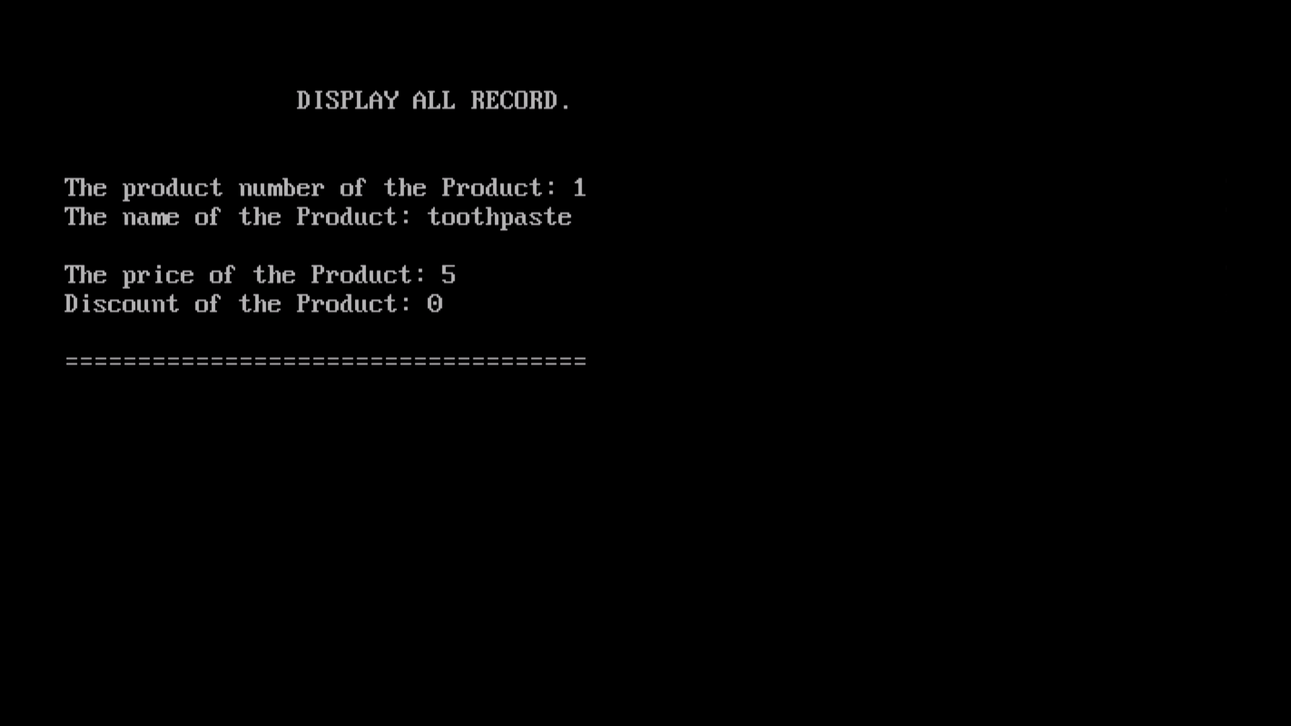

Query

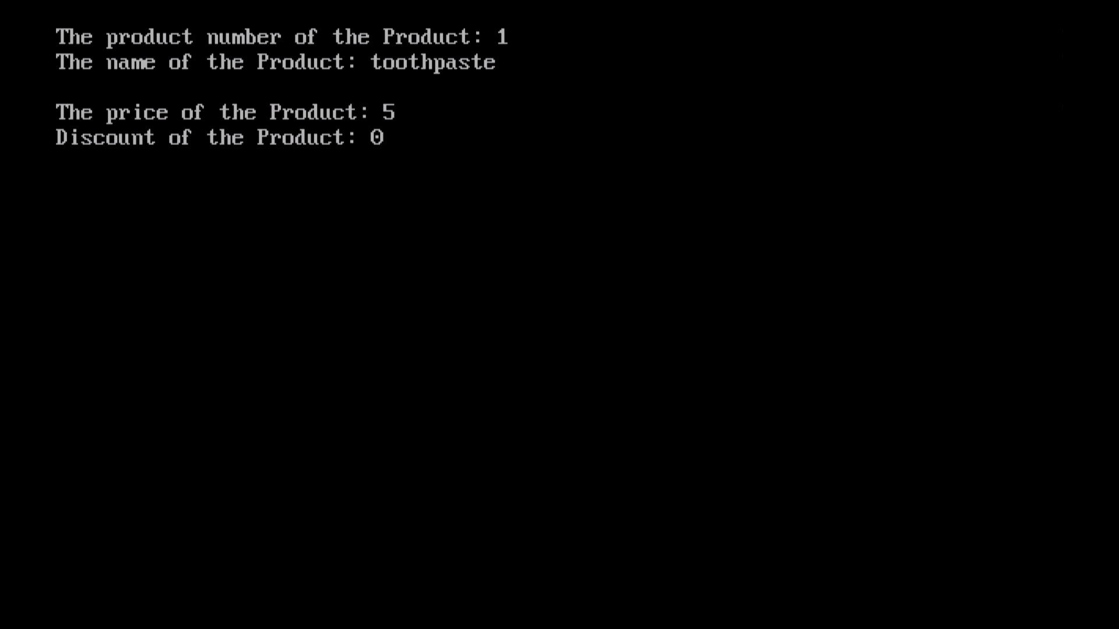

Modify Product

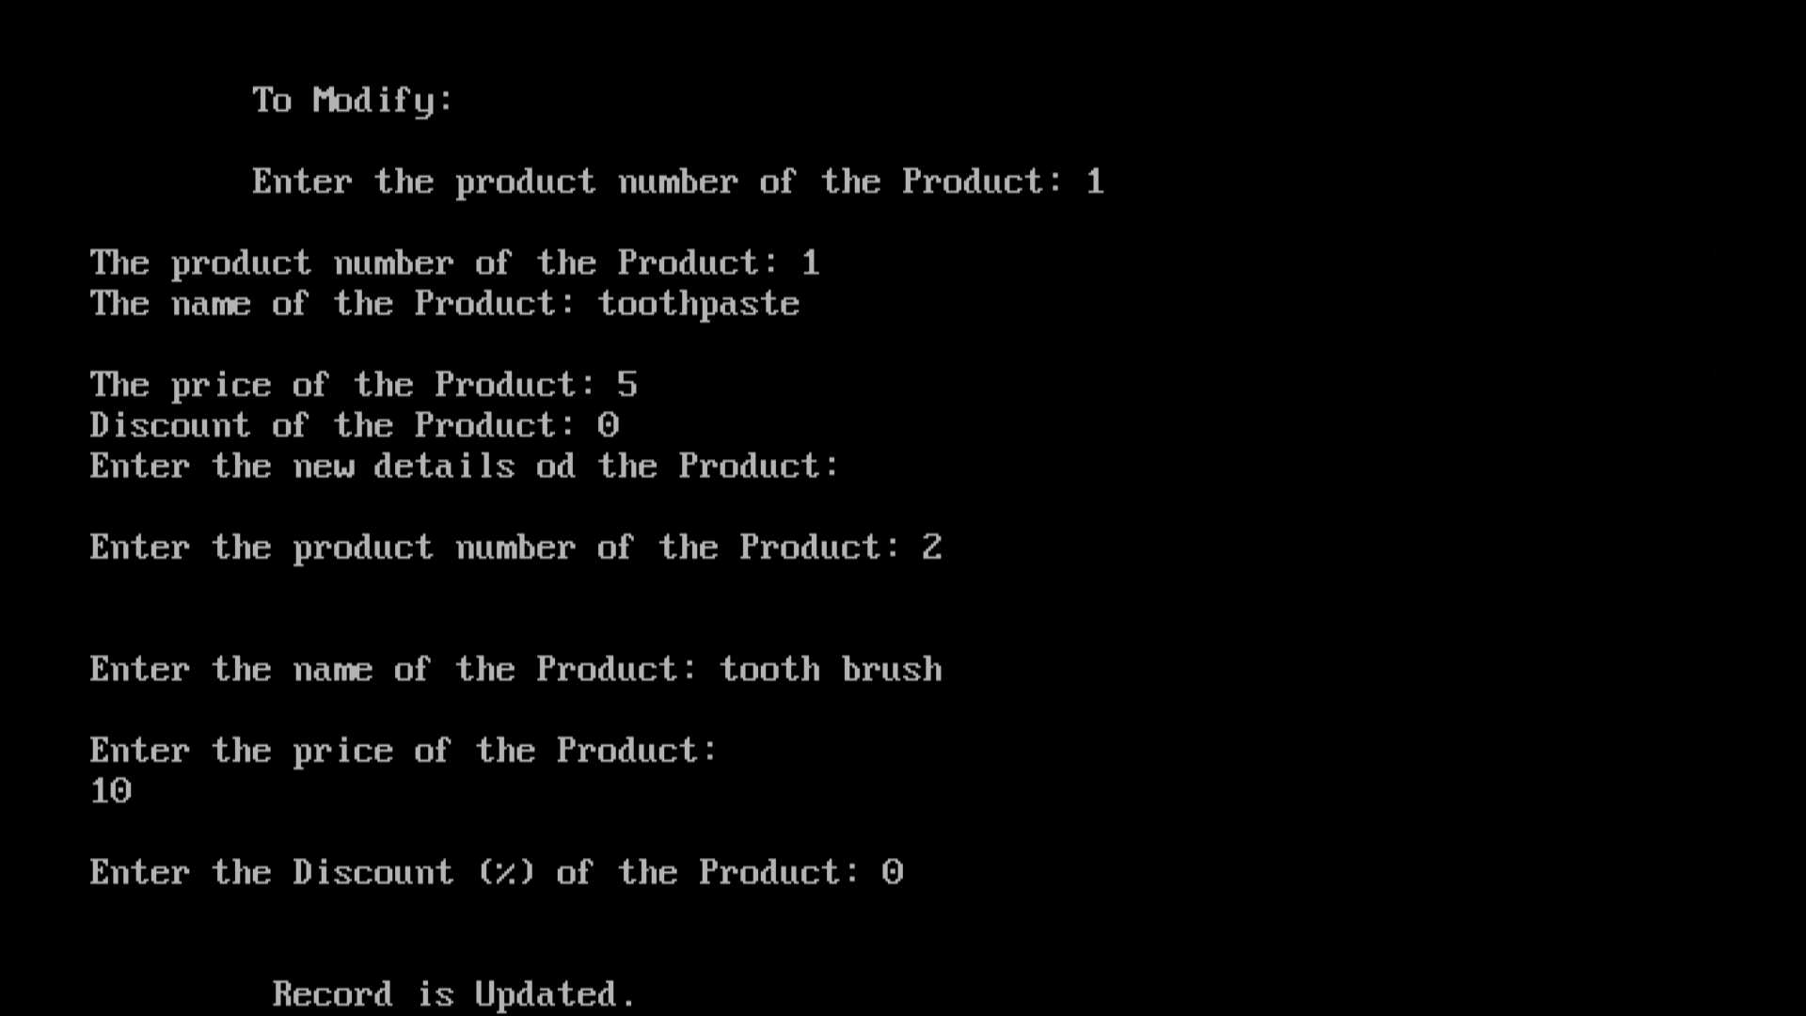

Delete Product

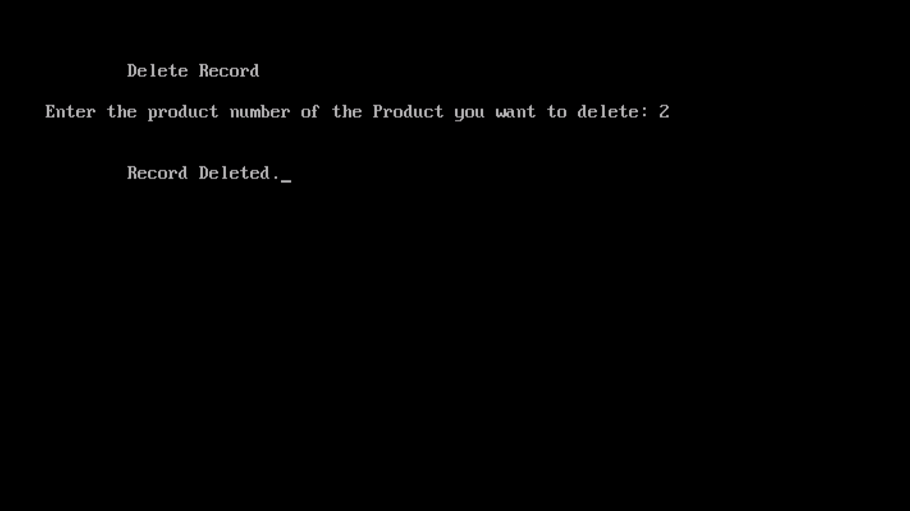

View Product

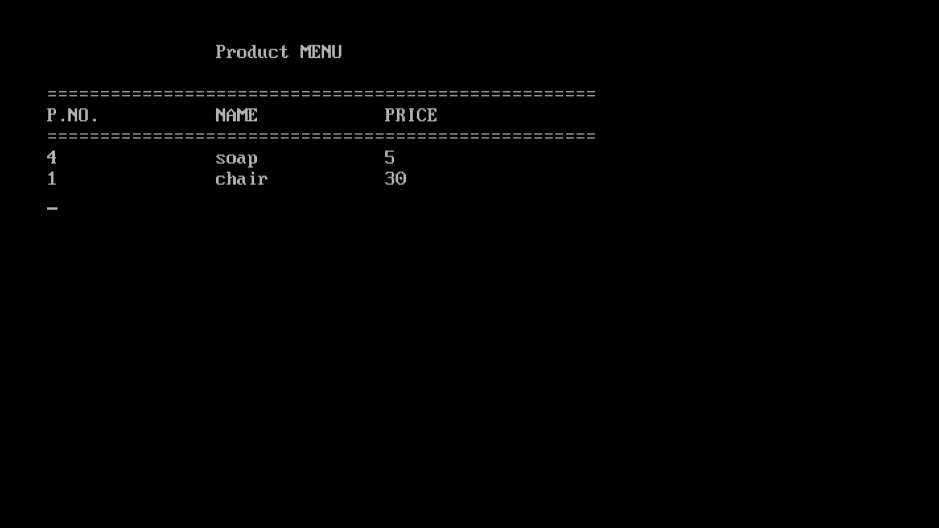

Customer Menu/Product Menu

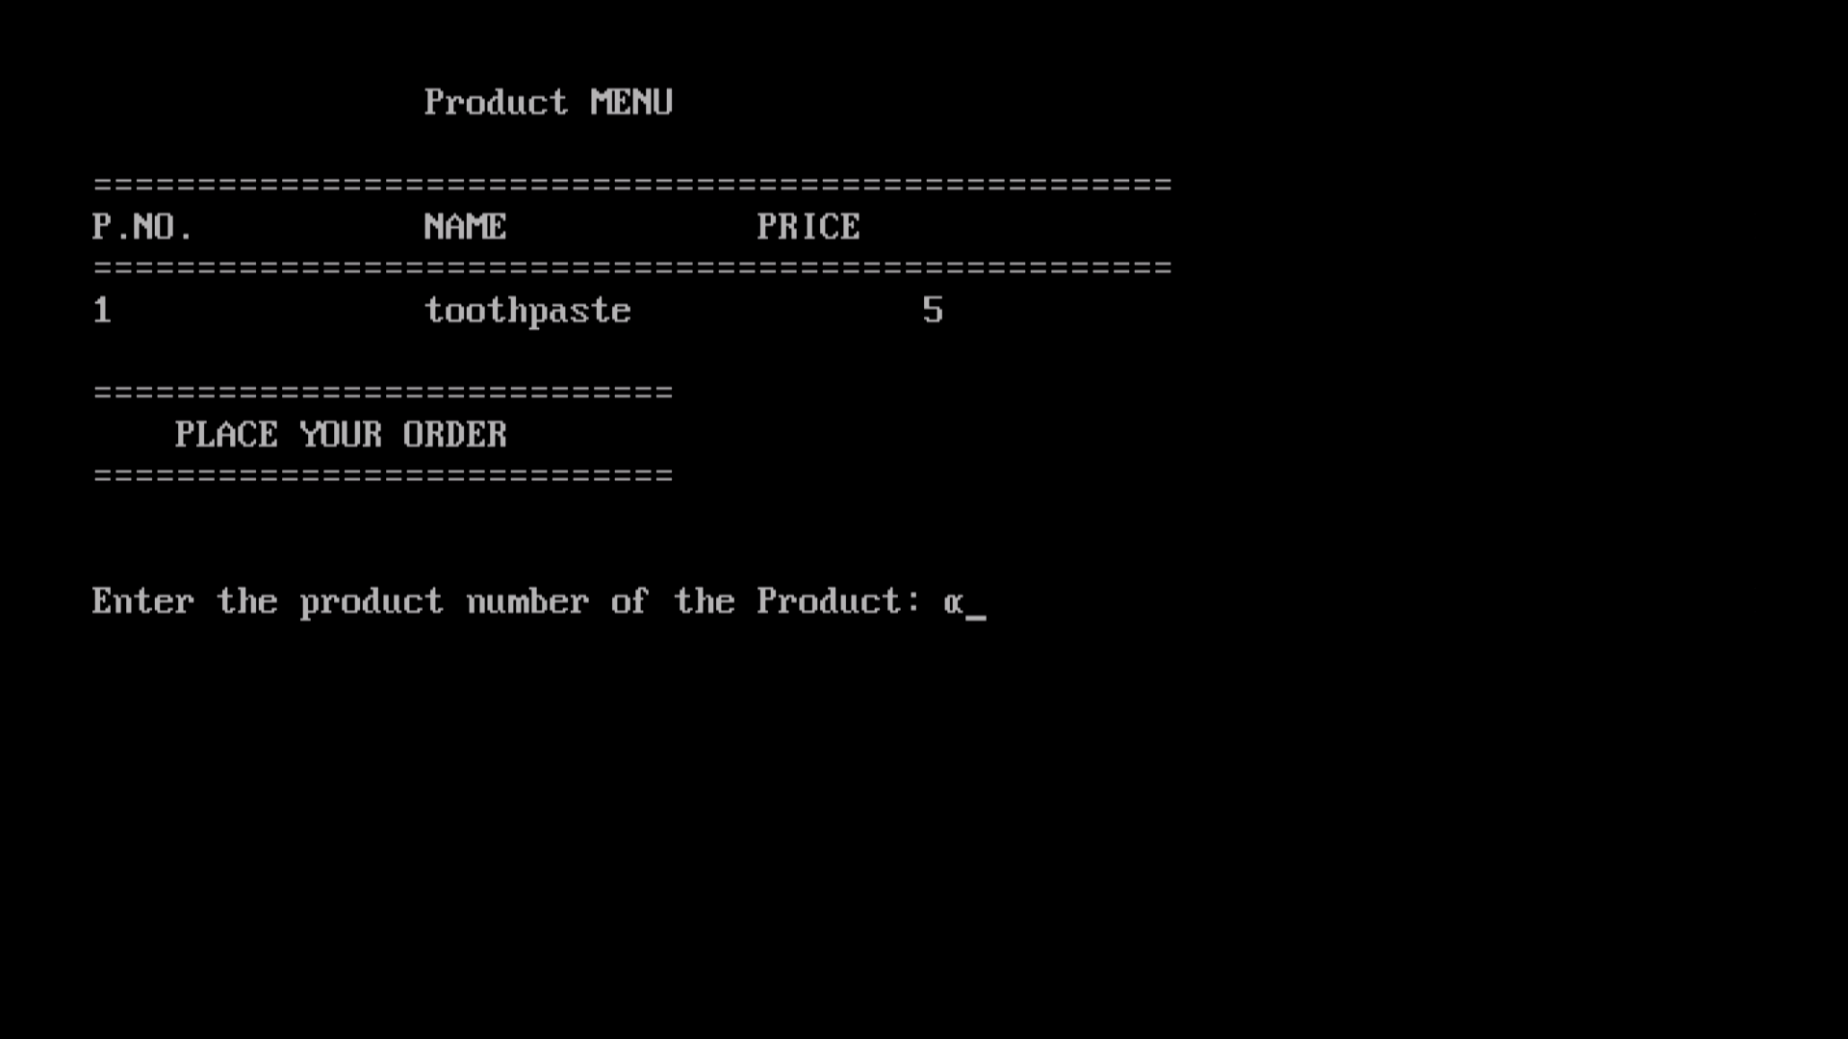

Placing Order

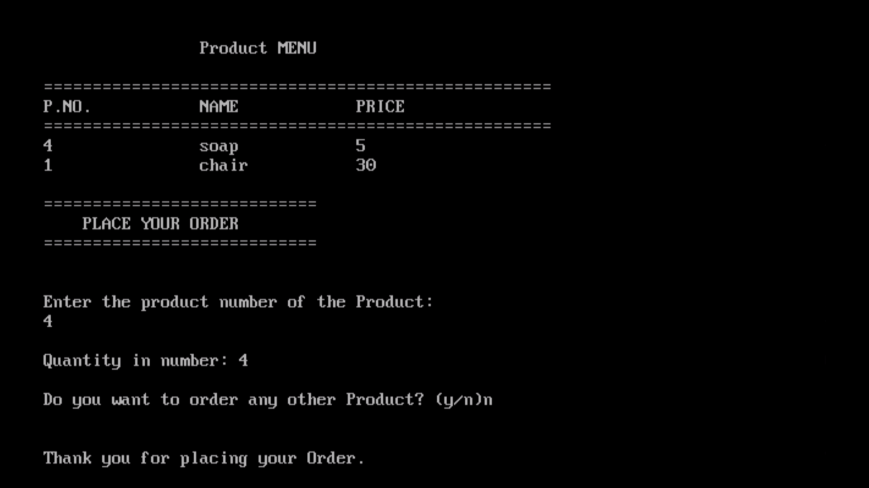

Invoice

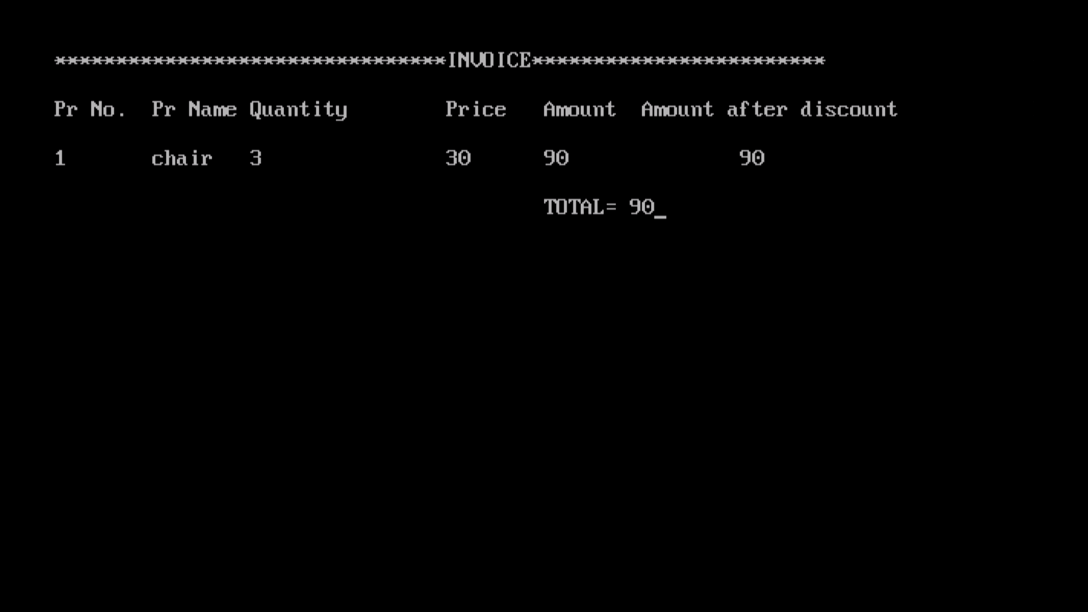

CONCLUSION:

There is a great necessity in meeting the increasing software needs in the modern world which formally looks forward for a computerized world.

The super markets all over the world are very important places since it allows us to buy those stuff which we need for our daily life. In super markets, managing the bills is the crucial job for a person. We cannot afford to make any mistakes while calculating the bills. So, me and my friends planned to bring better and easy way of managing the super market billing system. This program can be operated easily by any user.

Through this, we were also able to dive deep into the object orient programming and data file handling.

I provide the right use of the “Super Market Billing System” project and thus to achieve an easy, efficient and time saving job for others.

BIBLIOGRAPHY:

1. Let us ‘C’ by Yashwant Kantikar
2. Software Engineering by Roger S. Pressman.
3. Computer Science, C++ By Sumita Arora.
4. The complete reference, C++ by Herbert Schild.

